THEORY QUESTIONS
1.
Use the diagram below to answer questions (a) and (b).
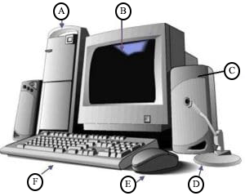
(a)

Identify the diagram.
(b)

Name the parts labelled A, B, C, D, E and F of the diagram.
(c)

List the five main components of a computer keyboard.
(d)

Give the stages involved in the information processing cycle.
(e)

List, in the right order, the steps involved in turning off a personal computer

2.
(a)

State the function of each of the following devices.
(i)

Floppy disk;
(ii)

Printer;
(iii)

Scanner;
(iv)

Uninterruptible power supply.
(b)

Write the following in full:
(i)

ALU
(ii)

CPU

3.
(a)

Explain the following types of software
(i)

System software;
(ii)

Application software.
(b)

State the function of each of the following buttons as used in application software.
(i)

Minimize
(ii)

Maximize
(iii)

Close

4.
(a)

Explain internet fraud.
(b)

State three ways ICT can be used in basic education in Ghana.
(c)

List three devices that may be used when connecting to the internet.
.
5.
Explain the following terms as used in spreadsheet:
(a)

Worksheet
(b)

Active cell
(c)

Range
(d)

Workbook

